**Manage the read from SDRAM and feed the VESA block**

From our presentation:

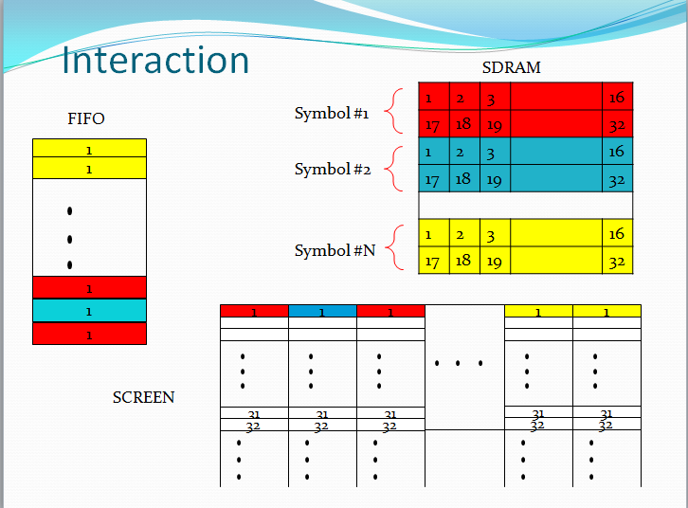

The signals we will use:

**Sym_row** = the row in terms of symbols, values: 0,…14

**Sym_col** = the col in terms of symbols, values: 0,…,19

**Row** = the row inside the current symbol, values: 0,…,31

Analogy to:

For **sym_row**=0 to 14

For **row**=0 to 31

For **sym_col**=0 to 19

Getting the DATA from the RAM:

For a given **sym_row** and **sym_col** : RAM_ROW <= 20\***sym_row** + **sym_col**;

Calculating the address in the SDRAM:

* If **row**=0…15 then we will use the first row of the symbol in the SDRAM.

Row_SDRAM <= RAM_DATA_o&'0';

Col_SDRAM <= 16\***row**;

Length of the burst is 16 words (each 16 bits)

* If **row**=16…31 then we will use the second row of the symbol in the SDRAM.

Row_SDRAM <= RAM_DATA_o&'1';

Col_SDRAM <= 16*(**row**-16);

Length of the burst is 16 words (each 16 bits)